A picture containing clipart

Description generated with very high confidence

Azure 103 Module 6

Hands on - 3

Azure Certification Training

[**support@intellipaat.com**](mailto:support@intellipaat.com)

**+91-7022374614**

**US: 1-800-216-8930(Toll Free)**

**Azure 103, Module 6, Hands On - 3**

**Problem Statement: Add or delete users using Azure Active Directory.**

**Solution:**

**To add a new user:**

**Step 1:** Sign into the [Azure portal](portal.azure.com) and search for Azure active directory in search bar the click on “**New user”** option.

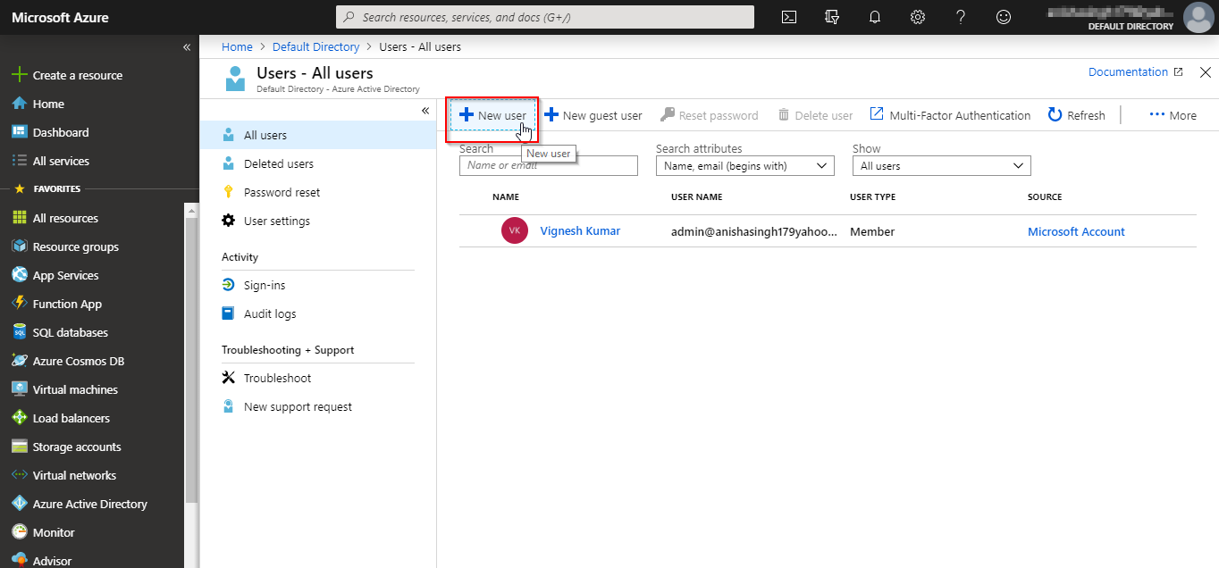

**Step 2:** You will get two options, one for creating a user and second for adding a user as a guest. Select the first option that is to create a user. Fill in the information about the user and copy the password and keep it somewhere safe.

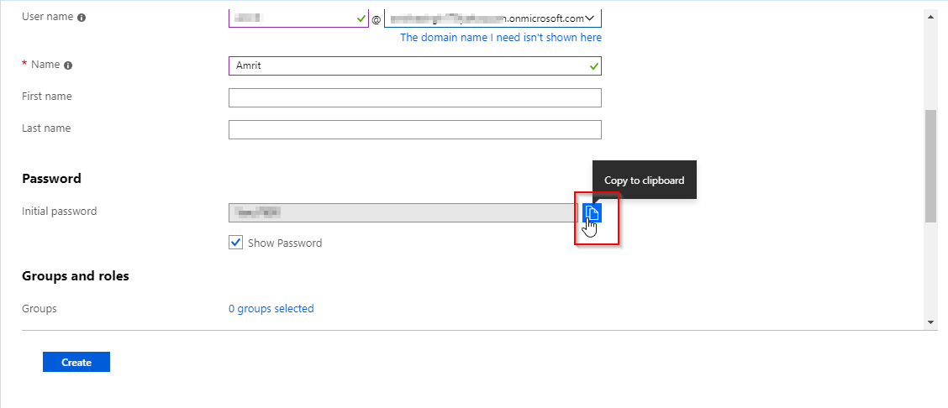

You can fill in information for the fields that are not mandatory as per your convenience, and then click on create.

**Step 3:** You will see that the user has been created and listed in the **users** page.

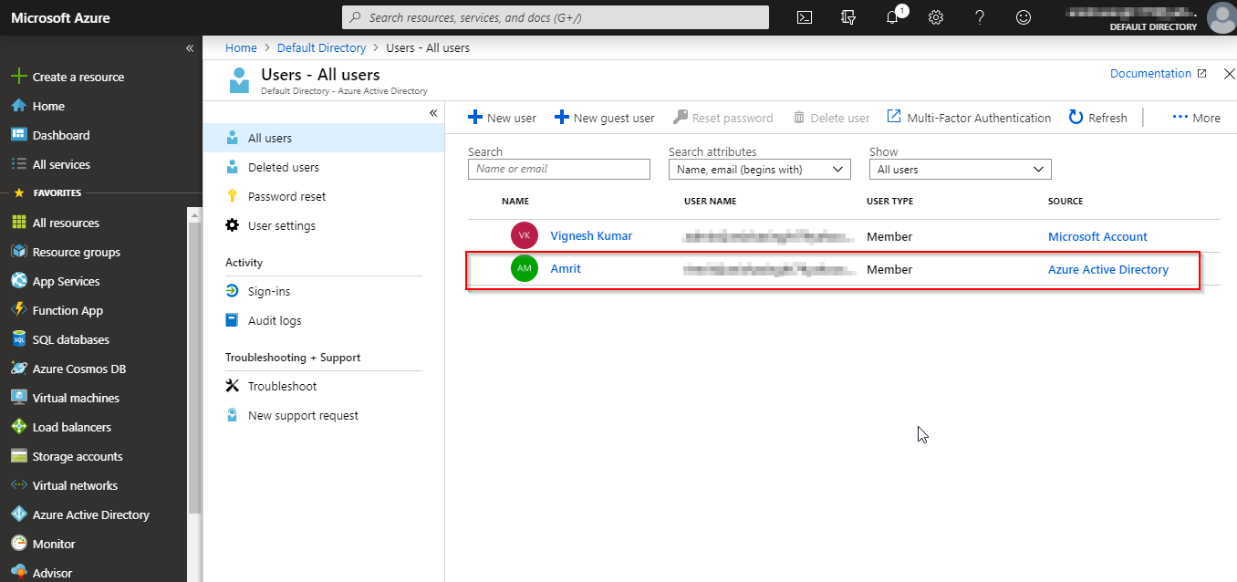

**To delete a User:**

**Step 1:** Select the user that you want to delete and then click on delete user option.